**Achievements of Empire**

**Do stop apologizing, Dave: How the PM feels compelled to knock Britain abroad**

**By Max Hastings**

**MailOnline, 8 April 2011**

For more than 200 years, Britain’s empire was a source of passionate national pride, and also the admiration and envy of foreigners.

In 1922, the American philosopher George Santayana enthused: ‘Never since the days of heroic Greece has the world had such a sweet, just, boyish master. It will be a black day for the human race when scientific blackguards, churls and fanatics manage to supplant him.’

This was gush, of course, because neither the Greeks nor Britain’s imperialists were as nice as Santayana suggested. It is a trifle embarrassing to glance through a little book published in Malaya in 1928, entitled Malay For Mems — short for ‘Memsahibs’.

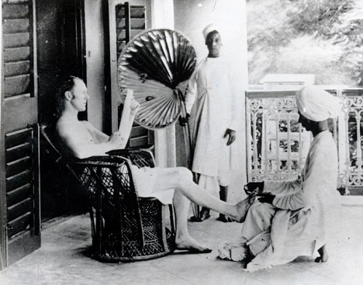

*Days of the Raj: Looking back, it is easy to caricature the early empire builders,* ***but their contribution to civilisation was immense***

This was designed to teach new arrivals in the colony the sort of phrases they needed to run households with lots of native servants. It was couched almost exclusively in the language of command: ‘Put up the tennis net’, ‘You must follow the Mem’, ‘Shoot that man’.

But everything in history should be judged by the standards of its time, custom and practice across the rest of the globe. Compared with its French, German, Belgian, Spanish, Portuguese and Italian counterparts, the British Empire was a model of enlightenment.

The men who governed the Empire, pro-consuls in palaces and district officers travelling vast tracts of  wilderness by pony or canoe, are easy to caricature. They believed in God and cold showers, donned evening dress for dinner in the midst of deserts and jungles, and cherished a touching belief in ‘playing up and playing the game’.

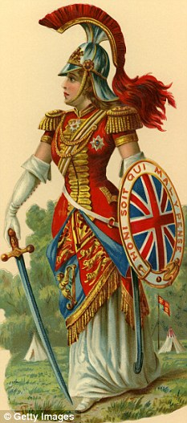

*Pax Britannica: Imperial Britain achieved much that we can take pride in*

**But many of them were decent, dedicated, honourable men who devoted their lives to the people among whom they served.**

They built marvellous roads, railways and bridges; tended the sick and afflicted; administered justice fairly, in a fashion few corners of the old Empire have known since they departed.

**Look around the world today and see the legacy of Empire: America, greatest society of all, was a British invention. Australia, Canada, New Zealand, dynamic democracies, were created by British imperialists.**

Indians, rejoicing in their new  economic success, never cease to acknowledge their gratitude that we bequeathed them the English language, a huge advantage against the Chinese. And I would suggest that while much of modern Africa  is a tragedy, it is a tragedy made  by Africans, not by British colonialists.

Their motives were not unselfish, to be sure, but their contribution to global civilisation was extraordinary, and largely benign.

The British Empire fought on the side of freedom and virtue in two world wars, and remains the  greatest power of its kind the world has ever seen.

Today it is history, but its heroes still deserve to be our heroes: Drake and Clive, Wellington, Campbell and Napier. You may not have heard of General Sir Charles Napier, but  he gave birth to one of the best  Victorian jokes. (Having conquered the Indian province of Sind in 1843, he supposedly sent the one-word message to Delhi: ‘Peccavi’ — in that age of Latinists, ‘I have sinned’. I love it.)

As a historian, I can recite plentiful examples of horrors that took place under British rule. But a fundamental reality persists: we did better than anyone else. As an Englishman, I feel a pride in the achievements of Empire not much diminished by knowing that we got some things wrong.

That is why it is dismaying to hear that, during the Prime Minister’s visit to Pakistan this week, he has delivered yet another public apology for the alleged imperial misdeeds of our ancestors. He was asked by an audience of academics and students what Britain might do to help heal the country’s bitter Kashmir dispute with India.

He answered: ‘I don’t want to try to insert Britain in some leading role where, as with so many of the world’s problems, we are responsible for the issue in the first place.’

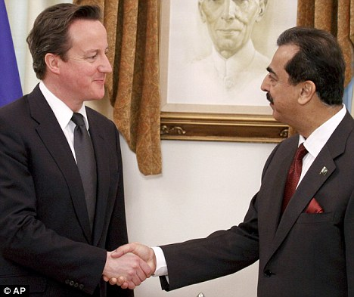

*Eager to please: David Cameron, left, shakes hand with Pakistani Prime Minister Yousuf Raza Gilani prior to their meeting in Islamabad earlier this week*

Oh dear, oh dear. By saying this, he is venturing where so many Leftist politicians, writers and filmmakers have gone before.

Tony Blair could not disembark from an aircraft in foreign parts without donning sackcloth and ashes for his country’s old sins: the Irish potato famine and slave trade prominent among them.

Richard Attenborough loved making historically fatuous films such as Gandhi, which depicted British imperialists in India as murderous monsters.

We might suggest, in defence of Blair and Attenborough, that they do not know any better. They learned little history at school, and have spent most of their lives in the company of people who, though British, do not think much of Britain.

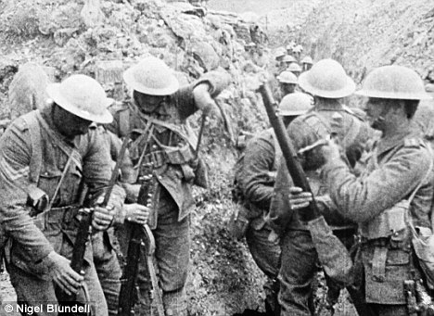

*Proud history: From Waterloo to two world wars, Britain has always stood up for democracy and freedom*

But Cameron attended what is probably the best school in the world, Eton, and is a highly educated man. He is also a Tory — indeed, leader of the Conservative Party. Thus, it does not seem too much to hope that he knows something of Britain’s past, and takes pride in it.

He and I come from different generations, but we both grew up in a culture in which British history was perceived as a splendid procession of battlefield triumphs — Crecy and Agincourt, Blenheim and Ramillies, Trafalgar and Waterloo — over such lesser races as the French. I am teasing a little, but you know what I mean.

As an admirer of Cameron, I was saddened that in Washington last summer he chose to flatter  Americans by asserting that Britain was the ‘junior partner’ in the 1940 struggle against Hitler. In truth, of course, at that date the United States was still neutral.

A brutally tough wartime U.S. administration required Britain to pay cash on the nail for every ton of arms shipped across the Atlantic to assist our lonely struggle for survival.

It is still uncertain whether the Americans would ever have joined the German war, had Hitler not declared war on the United States after the Japanese bombing of Pearl Harbour in December 1941.

And so to Cameron’s  gaffe — for it certainly was a gaffe — in Pakistan this week. It is easy to see how it happened. The Prime Minister is a man of natural good manners, which include modesty and a willingness to apologise.

Most of us, in a collision with a third party running for a train, instinctively blurt ‘sorry’ before stopping to consider that it was actually the other person’s fault.

But this is a very dangerous habit for national leaders, whose every word is weighed by millions of people.

They must never forget that, even as they address an audience in a hall, there is another much larger one around the world outside.

Cameron made an emollient remark which certainly pleased the Pakistani students in front of him. But back home are almost 60 million British people, many of whom will be much less impressed by their prime minister’s casual acceptance of blame for something that happened 64 years ago, on the far side of the world.

The history of the sub-continent remains a focus of fierce controversy, as much in India and Pakistan as among Western historians.

**The British, French and Portuguese established settlements there in the 17th century, when this vast region was ruled by local emperors, kings and princes who warred and killed with endemic cruelty. The great Hindu and Muslim civilisations seldom lived at peace.**

Through the 18th and 19th centuries, the British progressively extended their hegemony, mostly through war, until they controlled the entire sub-continent. But substantial areas remained under the rule of local grandees, albeit under the wider authority of the Queen-Emperor.

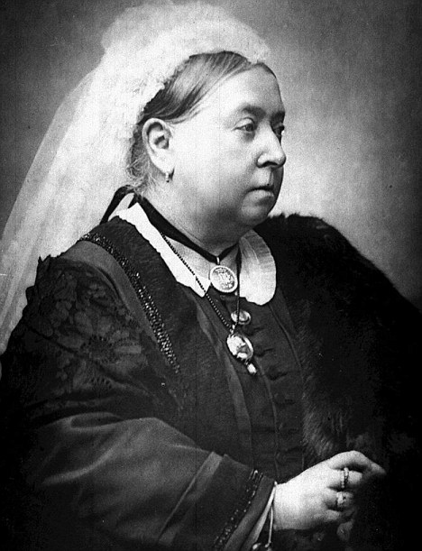

*Empress of India: Queen Victoria was head of the largest Empire the world has ever seen*

Kashmir was one of these ‘princely states’. By a quirk of fortune, its people were overwhelmingly Muslim, while its ruler was  a Hindu.

When Lord Mountbatten, the last Viceroy, presided over the partition of India at its independence on August 15, 1947, he left the Kashmiris to choose allegiance between their two neighbours — Muslim Pakistan or Hindu India.

The ruler opted for India, in defiance of the wishes of his people. India’s first prime minister,  Jawaharlal Nehru, promised the Kashmiri people the right to decide their destiny by referendum.

But to this day none of his successors has fulfilled the pledge. The consequence is that Kashmir remained the contested symbol of bitter hatred between India and Pakistan. Pakistanis foment terrorism in the state, fortified by  knowledge that most Kashmiris, given a free choice, would join their country. The Indians, meanwhile, rely on force majeure to keep what they hold.

Of course, there was a fragment of truth in what Cameron told  his Pakistani audience this week: Britain presided over the partition of India.

But it is hard to see how Mountbatten or anyone else could have made choices and decisions which would have saved its people from the murderous sectarian passions of Muslims and Hindus which prompted the massacres of at least half a million, probably  many more.

**Six million Hindus and Sikhs fled from the new Pakistan, while six-and-a-half million Muslims quit India in the largest mass migration in human history.**

**For almost a century, the Pax Britannica had sustained a peace and stability such as the sub-continent had never known, but independence rent this asunder.**

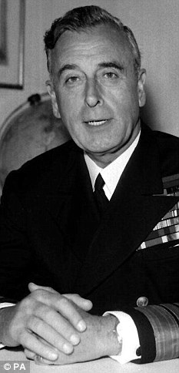

*The last Viceroy: Lord Mountbatten presided over the partition of India*

To be sure, in the last years before 1947 and especially during World War II, the British ruled with  considerable harshness.

The 1943 Bengal famine, in which at least one million and perhaps three million people died, remains a lasting blot on the imperial record.

Churchill’s entrenched attitude to the Raj was determined by his experience there as a Victorian cavalry subaltern. Leo Amery, his wartime Cabinet colleague, wrote that ‘Winston is not quite normal on the subject of India’.

But all this is a very long day’s march from saying that Britain bears responsibility for what happened to India in 1947 — and afterwards.

For all India’s economic success, the sub-continent remains riven by hatreds, strife, famines, miseries inflicted by the caste system. No grown-up person, or indeed historian, should be so simplistic as to blame much of this on the old imperial power.

David Cameron observed that many of the world’s other problems were likewise our fault, and maybe he was thinking of Ireland.

I am among those who believe that the 1922 partition at Irish independence was a mistake. But it derived from hatreds between Protestants and Catholics as bitter as those between Muslims and Hindus.

The British, in admittedly clumsy fashion, sought to separate the warring parties, to prevent the two from slaughtering each other, as they had so often done in the past — and would do again in our own times.

Successive British governments who addressed the ‘Irish problem’ which haunted these islands for centuries did not do very well. But they acknowledged a basic truth which David Cameron will learn to recognise from his own experience as prime minister.

There are seldom, if ever, ‘solutions’ to great problems — whether in the Middle East,  Ireland, Africa, India, the Balkans. Politicians can only strive to manage them, to identify the least bad expedients available to protect human lives and avert outright catastrophe.

So it was for the British politicians struggling with the fate of Ireland in the closing days of 1921, and of India in 1947. They were decent men, faced with vast difficulties and violent passions, who did their best.

For 21st-century politicians to make ‘apologies’ for past blunders or failures is inherently absurd, for we have no power over the past.

Of course we would have done things differently, because we are different people.

We would never say, as did Winston Churchill during World War II, that he would not permit British soldiers to salute Indian officers, because it would represent an intolerable humiliation to make them defer to ‘a brown man’.

But that is not because we are good people and Churchill was a bad one, it is because we live in another age.

I admire David Cameron, and believe that he has qualities that might make him a great prime minister. He diminishes himself, nonetheless, when he speaks ill of Britain abroad.

If our Prime Minister is not proud of his country, its past as well as its present, then it becomes all the harder to make the rest of its citizens honour our heritage as  we should.